Social Behavior Change: Radio and Mid-Media Implementation Report
December 2018
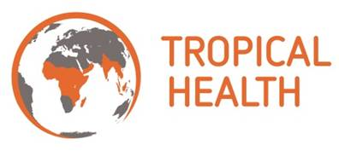
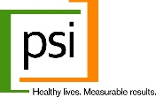
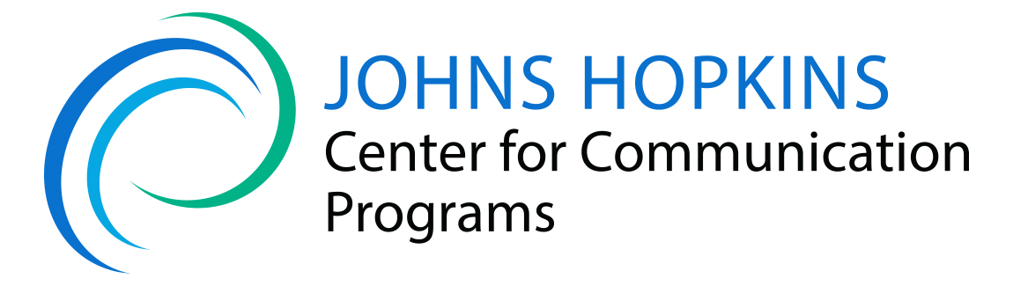
This report is made possible by the generous support of the American people through the United States Agency for International Development (USAID) and the President’s Malaria Initiative under the terms of USAID/JHU Cooperative Agreement No: AID-OAA-A-14-00057. The contents do not necessarily reflect the views of USAID, PMI or the United States Government.

Contents
Background 1
SBCC for Chandarua Kliniki Program 1
Road Show Activities 1
Radio Campaign 2
Omnibus Survey 3
Overview 3
Exposure 4
Knowledge 4
Age Groups 5
Conclusion 5

Abbreviations
ANC  BCC  CCP  DFID  EPI  GFATM  GES  GoG | Antenatal care  Behavior change communication  Johns Hopkins Center for Communication Programs  UK Department for International Development Expanded Program of Immunization  Global Fund for AIDS, Tuberculosis and Malaria  Ghana Education Service  Government of Ghana
IRB | Institutional Review Board
ITN | Insecticide-treated net
MaVCOC | Malaria Vector Control Oversight Committee
MOH | Ministry of Health
MOP | Malaria Operational Plan
NMCP | National Malaria Control Programme
NMT | National Monitoring Team
Peers-RUN  PMI | Peers for Regular Use of Nets  President’s Malaria Initiative
PMP  PO | Performance Monitoring Plan  Program Officer
SHEP  TBD | School Health Program  To be determined
USAID | United States Agency for International Development
USG | United States Government
WHO | World Health Organization

Background
VectorWorks is a five-year, USAID-funded, global malaria prevention project. The purpose of the VectorWorks project is to support countries to achieve and maintain high levels of coverage and use of insecticide-treated nets (ITNs) as well as to facilitate the adoption of proven alternative vector management interventions, including those targeting specific sites or populations.
In Tanzania, VectorWorks works with National Malaria Control Program (NMCP) to ensure universal coverage of ITNs is attained and keep up strategies sustained through different delivery mechanisms such as school and health facility-based ITN distributions.
Along with ITN distribution, VectorWorks is supporting the government of Tanzania through the NMCP to implement mass media SBCC activities to promote national-level distribution of ITNs in health facilities (Chandarua Kliniki program) and in schools (SNP). In Year Four, VectorWorks conducted SBCC activities to intensify program awareness about processes and eligibility for obtaining an ITN for both SNP and Chandarua Kliniki. The targeted regions were Katavi, Kigoma, Morogoro, Pwani, Simiyu, Shinyanga, and Tabora and Zanzibar. The project has targeted messages about consistent use of ITNs, and proper care, repair, and washing of ITNs in basins in 14 regions with the highest malaria prevalence. It has reached communities with key messages for each focus area through experiential media in the form of road shows and public announcements in selected regions, districts, and wards. In the second half of Year Four, VectorWorks implemented a radio campaign to promote awareness of the national scale up of the Chandarua Kliniki program in the entire country.
Through an independent consultant, Infinite Company, VectorWorks conducted routine monitoring of the media work through radio. In Quarter Four (July – September, 2018) the project used an omnibus survey machinery assess message reach and people’s awareness on who are the target beneficiaries of Chandarua Kliniki.

SBCC for Chandarua Kliniki Program

Road Show Activities
VectorWorks conducted 878 road shows, reaching 645,888 people (266,864 males and 379,024 females) through community events in various wards of 9 district councils.
In Quarter Three, VectorWorks deployed experiential activities through road shows in Zanzibar to support re-introduction of community-based distribution of ITNs as well as share messages around general ITN use, care repair and proper washing of ITNs. Activities in Unguja and Pemba started on 24th August 2018 and ended on 22nd September 2018 having covered all 11 districts councils (7 in Unguja and 4 in Pemba). Prior to conducting these activities, VectorWorks conducted engagement meetings both in Unguja and Pemba. A total of 22 officials (mostly district cultural officers) attended.
The table below, shows the districts covered with road show activities, the number of events conduced per district, and the people that were reached directly, disaggregated by gender. In summary, there were a total of 290 road shows conducted in 11 districts covering total of 127,053 people (47,209 male and 79,844 female) in Zanzibar.
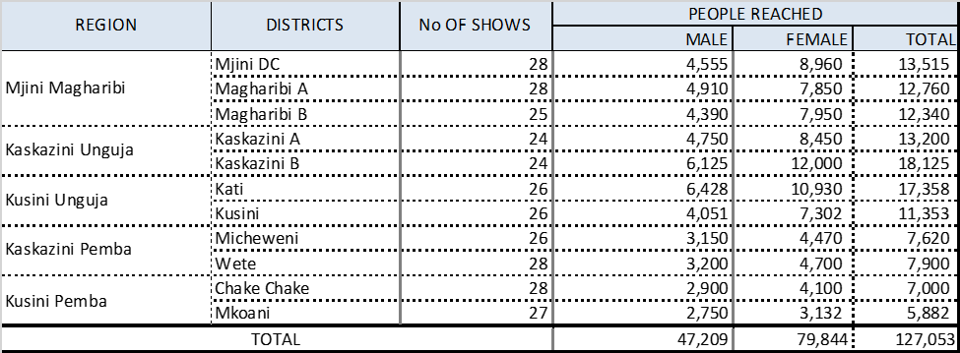
Radio Campaign
In Year Four, VectorWorks implemented a radio campaign to promote the national scale up of Chandarua Kliniki program in the entire country. The twenty-sixth and final region to launch the program was Manyara in mid-March 2018. In the third quarter, VectorWorks engaged Clouds FM Radio, which has highest national coverage (47%) and Radio Free Africa (25%), based on over 21 million listeners according to Tanzania All Media Product Consumption Survey.

The campaign aired from June to September. VectorWorks contracted the radio stations to air a total of 4,630 spots classified as Radio Spots, Talk Shows, Interviews, Presenter Mentions and Pre-recorded messages. VectorWorks engaged an independent media-monitoring agency (Infinite Media) to monitor and generate reports on media performance and compliance. Overall compliance rate for radio station to air contracted messages was 100%. A total of 5,756 spots were aired as per the media plans for the campaign period (June-Sept). This aggregate number of spots (5,756) aired reflects a bonus of 1,126 spots that were given to VectorWorks free of charge. Below is a table showing messages broadcasting for the month of August 2018.
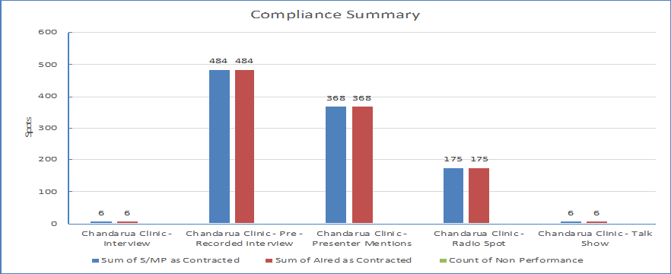

Omnibus Survey

Overview
In the fourth quarter of year four, VectorWorks put two questions (recall and knowledge of Chandarua Kliniki) into the Omnibus Survey to monitor the campaign reach draw. Ipsos conducted the survey from July to September 2018 involving a nationally representative sample of 2000 study respondents with 58% being female and 42% male.
Analysis of data showed exposure to Chandarua Kliniki message at 62% for those who either heard or seen the message “Chandarua Kliniki,” and 61% of respondents were knowledgeable about the beneficiaries of Chandarua Kliniki (see figure below).
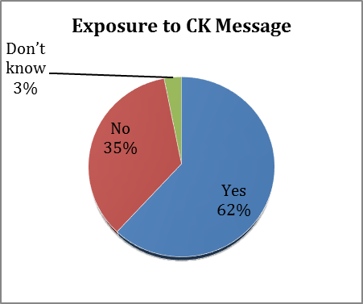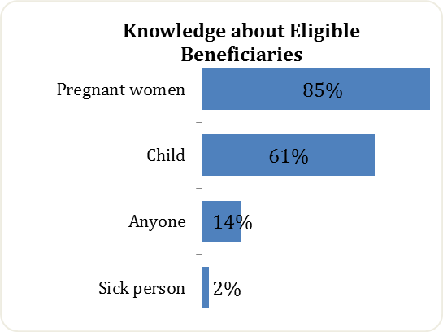

Exposure
Exposure is slightly higher among rural respondents (62.9%) as compared to those from the urban setting (59.5%); and the percentage of female (66.6%) who have heard or seen the message is greater than the male (55%).
 |  |  |  | Setting |  |  |  | Gender
Question |  | Total |  | Urban |  | Rural |  | Male |  | Female
Have you ever heard or seen the message, “Chandarua Kliniki?” | Total | 2000 | 100% | 690 | 100.0% | 1310 | 100.0% | 836 | 100.0% | 1164 | 100.0%
 | Yes | 1236 | 62% | 411 | 59.5% | 825 | 62.9% | 460 | 55.0% | 776 | 66.6%
 | No | 702 | 35% | 260 | 37.6% | 442 | 33.7% | 341 | 40.7% | 361 | 31.0%
 | Don’t know | 62 | 3% | 19 | 2.7% | 43 | 3.2% | 35 | 4.2% | 27 | 2.3%

Knowledge
Urban and rural as well as male and female respondents had similar knowledge about the eligible groups to receive ITNs through Chandarua Kliniki program.

 |  |  |  | Setting |  |  |  | Gender
Question |  | Total |  | Urban |  | Rural |  | Male |  | Female
Who is eligible to receive an ITN through Chandarua Kliniki | Total | 1236 | 100.0% | 411 | 100.0% | 825 | 100.0% | 460 | 100.0% | 776 | 100.00%
 | Pregnant women | 1050 | 84.9% | 356 | 86.6% | 694 | 84.1% | 375 | 81.52% | 675 | 86.98%
 | Child | 754 | 61.0% | 247 | 60.1% | 507 | 61.4% | 247 | 53.70% | 507 | 65.34%
 | Sick person | 30 | 2.4% | 12 | 2.9% | 18 | 2.1% | 16 | 3.48% | 14 | 1.80%
 | Anyone/ community member | 170 | 13.7% | 51 | 12.4% | 119 | 14.4% | 70 | 15.22% | 100 | 12.89%
 | Don’t know | 12 | 0.9% | 4 | 0.9% | 8 | 0.9% | 5 | 1.09% | 7 | 0.90%

Age Groups
The table below shows that majority (88.05%) of the study respondents were of reproductive age group (18 -49 years) which overlaps with the likely beneficiaries of the program.

Conclusion
Results from Omnibus suggest the radio campaign and mid-media activities implemented were successful and enabled creation of such high recall and knowledge about the Chandarua Kliniki program.

